JOIN is an SQL clause used to query and access data from multiple tables, based on logical relationships between those tables.

SQL JOIN operations are used to combine rows from two or more tables based on a related column between them. These operations enable the retrieval of data from multiple tables in a single query, based on logical relationships between those tables, allowing for more complex and meaningful queries.

The primary purpose of JOIN operations is to retrieve and consolidate data from multiple tables in a single query. This is particularly useful in relational database management systems where data is distributed across different tables, and relationships between tables exist.

**Advantages of Using SQL JOIN Operations:**

1. **Data Retrieval:**
   * JOIN operations allow users to retrieve data from multiple tables in a single query, reducing the need for multiple queries and improving efficiency.
2. **Data Normalization:**
   * Normalization is the process of organizing data to reduce redundancy. JOIN operations enable the storage of related information in separate tables, promoting data normalization.
3. **Complex Querying:**
   * JOINs facilitate the execution of complex queries involving multiple tables and relationships, providing flexibility and power in querying.
4. **Consistent and Accurate Results:**
   * By using JOINs, users can ensure that the data retrieved is consistent and accurate since relationships between tables are explicitly defined.
5. **Improved Performance:**
   * In some cases, JOINs can improve performance by allowing the database engine to optimize queries and access data more efficiently.

Inner Join

The INNER JOIN keyword selects records that have matching values in both tables. INNER is the default join type for JOIN, so when you write JOIN the parser actually writes INNER JOIN.

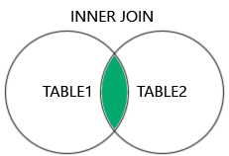

SELECT column_name(s)  
FROM table1  
INNER JOIN table2ON table1.column_name = table2.column_name;

-- join the Customers and Orders tables when

-- the customer_id from Customers matches the customer column in Orders

SELECT Customers.customer_id, Customers.first_name, Orders.amount

FROM Customers

JOIN Orders

ON Customers.customer_id = Orders.customer;

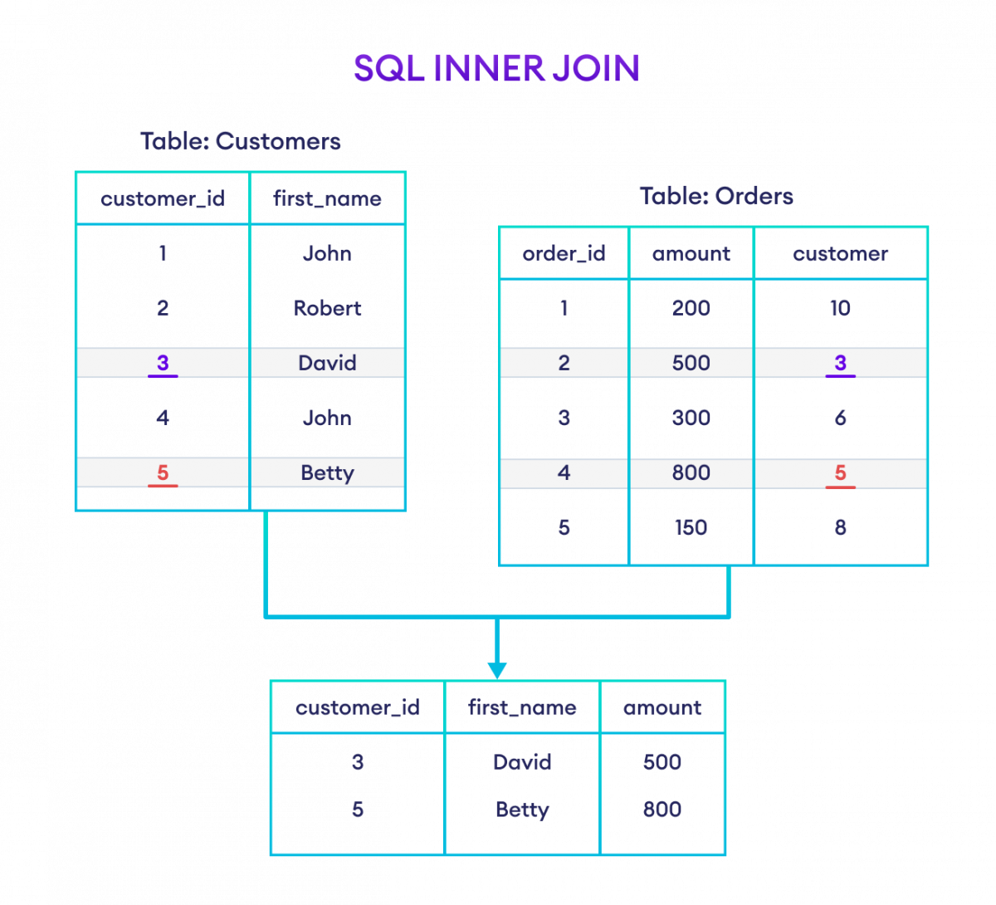

**Left Join**

The LEFT JOIN keyword returns all records from the left table (table1), and the matching records from the right table (table2). The result is 0 records from the right side, if there is no match.

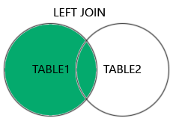

SELECT columns_from_both_tables

FROM table1

LEFT JOIN table2

ON table1.column1 = table2.column2

SELECT Customers.customer_id, Customers.first_name, Orders.amount

FROM Customers

LEFT JOIN Orders

ON Customers.customer_id = Orders.customer;

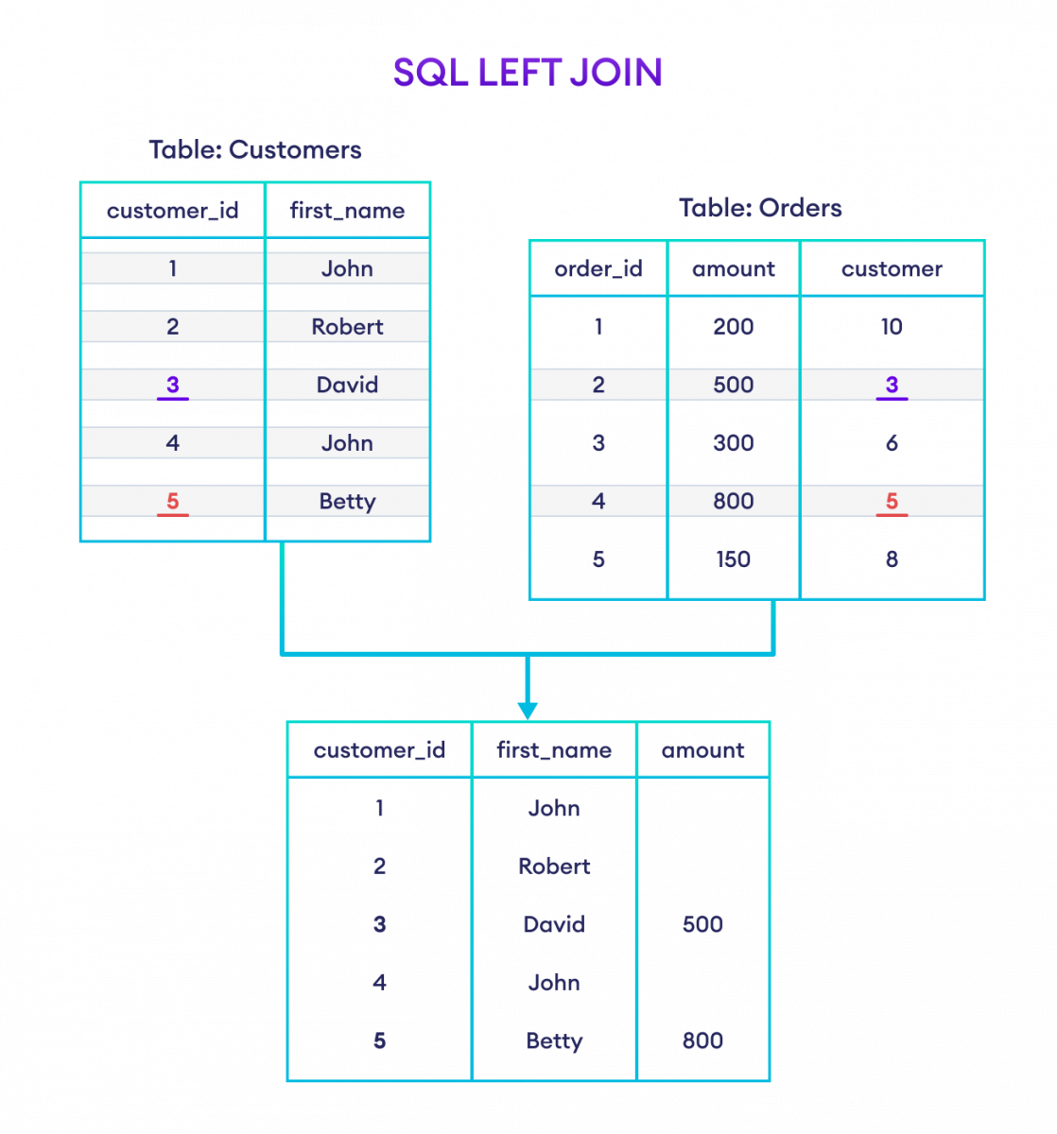

**Right Join**

The RIGHT JOIN keyword returns all records from the right table (table2), and the matching records from the left table (table1). The result is 0 records from the left side, if there is no match.

SELECT column_name(s)  
FROM table1  
RIGHT JOIN table2ON table1.column_name = table2.column_name;

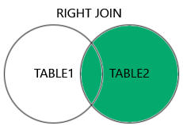

SELECT Customers.customer_id, Customers.first_name, Orders.amount

FROM Customers

RIGHT JOIN Orders

ON Customers.customer_id = Orders.customer;

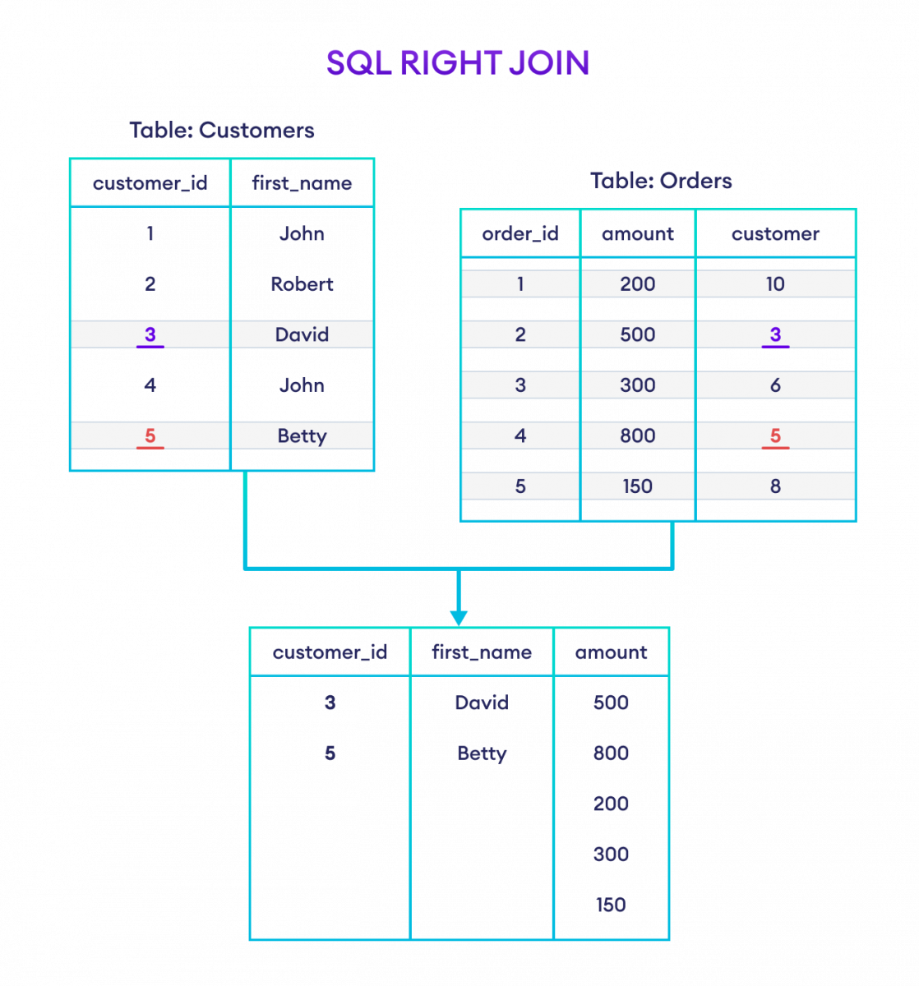

**Outer Join**

The FULL OUTER JOIN keyword returns all records when there is a match in left (table1) or right (table2) table records.

**Tip:** FULL OUTER JOIN and FULL JOIN are the same.

SELECT column_name(s)  
FROM table1  
FULL OUTER JOIN table2ON table1.column_name = table2.column_nameWHERE condition;

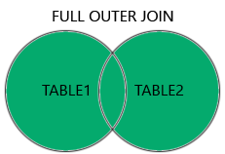

SELECT Customers.customer_id, Customers.first_name, Orders.amount

FROM Customers

FULL OUTER JOIN Orders

ON Customers.customer_id = Orders.customer;

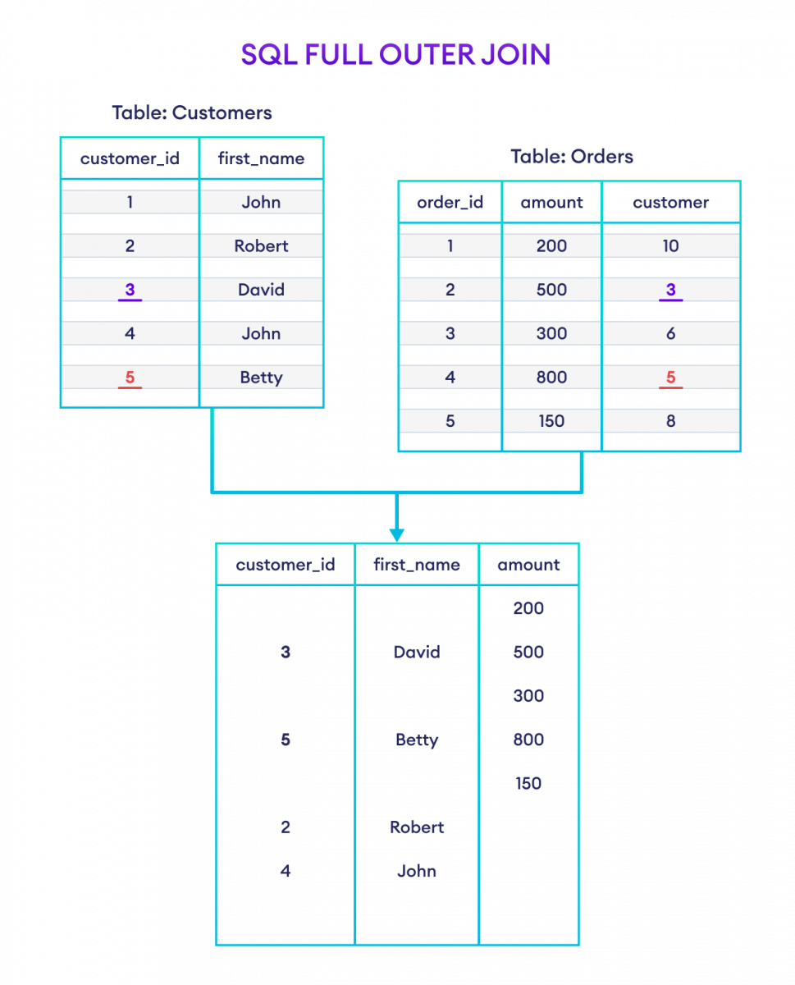

This type of JOIN is useful when you want to retrieve all records from one table and the matching records from another, even if there are no matches.

**Self Join**

A self-join in SQL occurs when a table is joined with itself. In other words, you use the same table for both the left and right sides of the join operation. This is useful when you want to combine rows within the same table based on related columns.

**Circumstances for a Self-Join:**

1. **Hierarchical Data:**
   * In scenarios where you have hierarchical data stored in a table, such as an organizational chart where employees report to other employees, a self-join can be used to retrieve information about both managers and their direct reports.
2. **Networks and Relationships:**
   * When dealing with networks or relationships between entities in the same table, a self-join can help identify connections and relationships.
3. **Comparisons within the Same Entity:**
   * If you need to compare records within the same entity based on certain criteria, a self-join can be handy.

SELECT column_name(s)  
FROM table1 T1, table1 T2  
WHERE condition;

1. Explain the purpose of SQL JOIN operations. Provide examples for INNER JOIN, LEFT JOIN, and RIGHT JOIN.
2. Explain the purpose of SQL JOIN operations and discuss the advantages of using them in database queries. Provide an example of an OUTER JOIN operation, along with its use case.
3. What is a self-join in SQL? Provide an example and describe a scenario where a self-join is useful.
4. What is a self-join in SQL, and under what circumstances might you encounter a self-join in real-world databases? Provide an example of a self-join query.
5. Define the first three Normal Forms (1NF, 2NF, 3NF) in database normalization. Provide examples to illustrate each form.

https://www.freecodecamp.org/news/database-normalization-1nf-2nf-3nf-table-examples/

Database normalization is a database design principle for organizing data in an organized and consistent way.

It helps you avoid redundancy and maintain the integrity of the database. It also helps you eliminate undesirable characteristics associated with insertion, deletion, and updating.

The main purpose of database normalization is to avoid complexities, eliminate duplicates, and organize data in a consistent way. In normalization, the data is divided into several tables linked together with relationships.

All the types of database normalization are cumulative – meaning each one builds on top of those beneath it. So all the concepts in 1NF also carry over to 2NF, and so on.

**The First Normal Form – 1NF**

For a table to be in the first normal form, it must meet the following criteria:

* a single cell must not hold more than one value (atomicity)
* there must be a primary key for identification
* no duplicated rows or columns
* each column must have only one value for each row in the table

**The Second Normal Form – 2NF**

The 1NF only eliminates repeating groups, not redundancy. That’s why there is 2NF.

A table is said to be in 2NF if it meets the following criteria:

* it’s already in 1NF
* has no partial dependency. That is, all non-key attributes are fully dependent on a primary key.

**The Third Normal Form – 3NF**

When a table is in 2NF, it eliminates repeating groups and redundancy, but it does not eliminate transitive partial dependency.

This means a non-prime attribute (an attribute that is not part of the candidate’s key) is dependent on another non-prime attribute. This is what the third normal form (3NF) eliminates.

So, for a table to be in 3NF, it must:

* be in 2NF
* have no transitive partial dependency.

## Examples of 1NF, 2NF, and 3NF

Database normalization is quite technical, but we will illustrate each of the normal forms with examples.

Imagine we're building a restaurant management application. That application needs to store data about the company's employees and it starts out by creating the following table of employees:

| **EMPLOYEE_ID** | **NAME** | **JOB_CODE** | **JOB** | **STATE_CODE** | **HOME_STATE** |
| --- | --- | --- | --- | --- | --- |
| E001 | Alice | J01 | Chef | 26 | Michigan |
| E001 | Alice | J02 | Waiter | 26 | Michigan |
| E002 | Bob | J02 | Waiter | 56 | Wyoming |
| E002 | Bob | J03 | Bartender | 56 | Wyoming |
| E003 | Alice | J01 | Chef | 56 | Wyoming |

All the entries are atomic and there is a composite primary key (employee_id, job_code) so the table is in the **first normal form (1NF)**.

But even if you only know someone's employee_id, then you can determine their name, home_state, and state_code (because they should be the same person). This means name, home_state, and state_code are dependent on employee_id (a part of primary composite key). So, the table is not in **2NF**. We should separate them to a different table to make it 2NF.

### Example of Second Normal Form (2NF)

#### **employee_roles** Table

| **EMPLOYEE_ID** | **JOB_CODE** |
| --- | --- |
| E001 | J01 |
| E001 | J02 |
| E002 | J02 |
| E002 | J03 |
| E003 | J01 |

#### **employees** Table

| **EMPLOYEE_ID** | **NAME** | **STATE_CODE** | **HOME_STATE** |
| --- | --- | --- | --- |
| E001 | Alice | 26 | Michigan |
| E002 | Bob | 56 | Wyoming |
| E003 | Alice | 56 | Wyoming |

#### **jobs** table

| **JOB_CODE** | **JOB** |
| --- | --- |
| J01 | Chef |
| J02 | Waiter |
| J03 | Bartender |

home_state is now dependent on state_code. So, if you know the state_code, then you can find the home_state value.

To take this a step further, we should separate them again to a different table to make it 3NF.

### Example of Third Normal Form (3NF)

#### **employee_roles** Table

| **EMPLOYEE_ID** | **JOB_CODE** |
| --- | --- |
| E001 | J01 |
| E001 | J02 |
| E002 | J02 |
| E002 | J03 |
| E003 | J01 |

#### **employees** Table

| **EMPLOYEE_ID** | **NAME** | **STATE_CODE** |
| --- | --- | --- |
| E001 | Alice | 26 |
| E002 | Bob | 56 |
| E003 | Alice | 56 |

#### **jobs** Table

| **JOB_CODE** | **JOB** |
| --- | --- |
| J01 | Chef |
| J02 | Waiter |
| J03 | Bartender |

#### **states** Table

| **STATE_CODE** | **HOME_STATE** |
| --- | --- |
| 26 | Michigan |
| 56 | Wyoming |

Now our database is in 3NF.

1. Define the concept of the Fourth Normal Form (4NF) in the context of database normalization. Provide an example that illustrates a 4NF-compliant table.

https://www.javatpoint.com/dbms-forth-normal-form

1. Describe the differences between Boyce-Codd Normal Form (BCNF) and Fourth Normal Form (4NF) in the context of database design. Explain with an example.

<https://www.geeksforgeeks.org/difference-between-bcnf-and-4nf-in-dbms/>

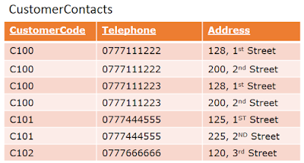

The definition of the *multi-valued dependency* goes as *Represent a dependency between attributes in a relation, such that for each value of A there is a set of values for B and set of values for C. However the set of values for B and C are independent of each other*. This dependency denotes as *A ->> B*.

See the *CustomerContacts*table. *CustomerCode* determines multiple *Telephone* (*CustomerCode ->> Telephone)*and *CustomerCode*determines multiple *Address (CustomerCode  ->>  Telephone)*.

The forth normal form is describes as *A relation that is in Boyce-Codd normal form and does not contain nontrivial multi-valued dependencies.* This talks about one type of *multi-valued dependency*that is *nontrivial*. *Trivial relationship*means; if B is subset of A or A U B = R. Else it is *Nontrivial*. As you see, *CustomerContact* contains *nontrivial dependencies*, hence need to decompose the table as below.

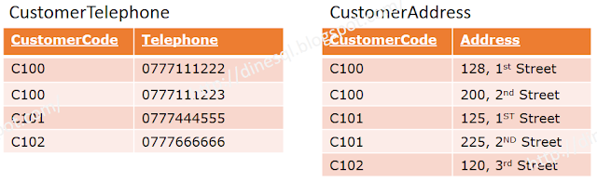

1. What is BCNF (Boyce-Codd Normal Form), and how does it differ from 3NF? Explain with an example.

<https://www.javatpoint.com/dbms-boyce-codd-normal-form>

Boyce-Codd Normal Form (BCNF) is a higher level of database normalization, stricter than Third Normal Form (3NF). It addresses a specific type of redundancy that can occur in 3NF relations, known as **transitive dependencies**. Transitive dependencies occur when there are non-prime attributes that are indirectly dependent on the primary key through another attribute.

**3NF** states that every non-prime attribute in a relation is directly dependent on the primary key. However, it does not eliminate the possibility of transitive dependencies.

**BCNF** addresses this issue by requiring that every non-prime attribute in a relation is directly dependent on all **candidate keys**. A candidate key is a minimal set of attributes that uniquely identify all the rows in a relation.

In simpler terms, BCNF ensures that no non-prime attribute is dependent on another non-prime attribute. This helps to reduce redundancy and improve data integrity in a database.

**Example:**

Consider a relation named EMPLOYEES with the following attributes:

EMP_ID (primary key)

EMP_NAME

DEPT_ID

DEPT_NAME

This relation is in 3NF because every non-prime attribute (EMP_NAME and DEPT_NAME) is directly dependent on the primary key (EMP_ID). However, there is a transitive dependency between DEPT_ID and EMP_NAME. This means that EMP_NAME is indirectly dependent on EMP_ID through DEPT_ID.

To eliminate this transitive dependency, we can further normalize the relation by dividing it into two relations:

EMPLOYEES

EMP_ID (primary key)

EMP_NAME

DEPARTMENTS

DEPT_ID (primary key)

DEPT_NAME

This decomposition eliminates the transitive dependency and ensures that the relation is in BCNF.

1. Discuss the importance of indexing in a database system. Explain how indexing can optimize queries, particularly for large datasets.
2. Describe what an index is in the context of a database. How does indexing improve query performance?

Indexing is a crucial technique in database management systems (DBMS) that significantly enhances data retrieval performance, especially for large datasets. It serves as a directory or roadmap for locating specific data within a table without having to scan through the entire table, reducing the time and resources required to execute queries.

**And**

In the context of a database, an index is a specialized data structure that improves the speed of data retrieval operations on a database table. It acts as a pointer or roadmap, allowing the database system to quickly locate specific pieces of information without having to scan through the entire table. This significantly reduces the time and resources required to execute queries, especially for large datasets.

Imagine a database table as a large library with books arranged by author name. Without an index, finding a specific book would require searching through every bookshelf, shelf by shelf. With an index, the librarian can quickly locate the book's location based on the author's name, saving time and effort.

Similarly, indexes in databases work by maintaining a separate data structure that maps specific values of one or more columns to the corresponding rows in the table. This mapping allows the database syste

**Optimizing Queries with Indexing:**

1. **Efficient Data Retrieval:** Indexes act as pointers, enabling the database system to quickly identify the exact location of the desired data, eliminating the need to examine every row in the table. This reduces the number of disk I/O operations, leading to faster query execution.
2. **Reduced Query Response Time:** By minimizing the amount of data that needs to be processed, indexing significantly improves the response time of queries, especially for complex queries that involve filtering, sorting, or joining data from multiple tables.
3. **Improved Scalability:** As the size of a dataset grows, indexing becomes even more critical. Without indexing, query performance degrades rapidly as the database grows, but with proper indexing, queries can continue to execute efficiently even with large datasets.
4. **Reduced Server Load:** Indexing minimizes the amount of data that the database server needs to process, reducing the overall load on the server. This frees up resources for other tasks, ensuring overall system responsiveness.
5. **Optimized Sorting and Joining:** Indexes are particularly beneficial for queries that involve sorting or joining data from multiple tables. They allow the optimizer to efficiently identify the relevant data and perform the operations in a more organized manner.

**Effectiveness of Indexing for Large Datasets:**

Indexing is especially effective for large datasets because it allows the database system to avoid scanning through vast amounts of data. As the dataset grows, the benefits of indexing become even more pronounced.

For instance, consider a table containing millions of customer records. Without indexing, a query to find a specific customer by their phone number would require scanning through every record, a time-consuming and inefficient process. With indexing, the database can quickly identify the relevant customer record, significantly improving query performance.

In conclusion, indexing plays a pivotal role in optimizing database performance, particularly for large datasets. It reduces query response time, improves scalability, and enhances overall system responsiveness. By efficiently directing the database to the desired data, indexing ensures that queries are executed quickly and efficiently, even for massive datasets.

1. Explain the differences between a unique index and a unique constraint in a relational database. Provide an example for each.

In a relational database, a unique index and a unique constraint are both mechanisms for ensuring that no duplicate values exist in a given column or set of columns. However, they differ in their implementation and scope:

**Unique Index:**

A unique index is a physical structure that is stored in the database and acts as a guide for quickly locating specific data values. It maintains a mapping between the values of the indexed column(s) and the corresponding rows in the table. This mapping allows the database system to efficiently identify and prevent duplicate entries during data insertion or updates.

**Example:**

Consider a table named EMPLOYEES with the following columns:

EMP_ID (primary key)

EMP_NAME

EMAIL_ADDRESS

To ensure that no employee has the same email address, a unique index can be created on the EMAIL_ADDRESS column:

SQL

CREATE UNIQUE INDEX IX_EMPLOYEES_EMAIL ON EMPLOYEES (EMAIL_ADDRESS);

Use code with caution. [Learn more](https://bard.google.com/faq#coding)

content_copy

This index will prevent any attempt to insert a new employee record with an existing email address, maintaining the uniqueness of email addresses among employees.

**Unique Constraint:**

A unique constraint is a logical rule that is enforced by the database system to ensure data integrity. It specifies that no duplicate values can exist in a given column or set of columns. Unlike a unique index, a unique constraint does not explicitly create a physical index structure. Instead, it relies on the database system's mechanisms to enforce the uniqueness rule.

**Example:**

Consider a table named COURSES with the following columns:

COURSE_ID (primary key)

COURSE_NAME

INSTRUCTOR_ID

To ensure that no two courses have the same name, a unique constraint can be defined on the COURSE_NAME column:

SQL

ALTER TABLE COURSES

ADD CONSTRAINT UNIQUE_COURSE_NAME UNIQUE (COURSE_NAME);

Use code with caution. [Learn more](https://bard.google.com/faq#coding)

content_copy

This constraint will prevent any attempt to insert a new course record with an existing course name, maintaining the uniqueness of course names.

**Key Differences:**

1. **Implementation:** A unique index is a physical structure, while a unique constraint is a logical rule.
2. **Index Structure:** A unique index maintains a mapping between values and rows, while a unique constraint does not.
3. **Enforcement Mechanism:** A unique index enforces uniqueness through its structure, while a unique constraint relies on the database system's mechanisms.
4. **Performance:** A unique index can improve query performance by providing a faster way to locate specific data values.
5. **Scope:** A unique index can be defined on multiple columns, while a unique constraint is typically defined on a single column or a set of non-key columns.

In general, both unique indexes and unique constraints serve the same purpose of maintaining data integrity by preventing duplicate values. The choice between the two depends on the specific requirements of the application and the desired balance between data integrity, performance, and storage utilization.

1. Explain the differences between clustered and non-clustered indexes in a database. Provide examples of situations where each type is beneficial?

https://www.geeksforgeeks.org/difference-between-clustered-and-non-clustered-index/

Clustered and non-clustered indexes are two types of indexes used in relational databases to improve data retrieval performance. They differ in their structure, implementation, and usage scenarios.

**Clustered Index:**

A clustered index is a special type of index that physically orders the data rows in a table based on the index key values. It maintains a direct mapping between the index key values and the corresponding data pages, allowing for efficient data retrieval and range queries.

**Benefits of Clustered Indexes:**

* **Efficient Data Retrieval:** Clustered indexes provide the fastest access to data for queries that involve filtering or sorting based on the index key columns.
* **Range Queries:** Clustered indexes are particularly efficient for range queries, as they allow the database to quickly identify the range of data pages to scan.
* **Reduced Disk I/O:** Clustered indexes can reduce disk I/O operations by minimizing the number of page reads required to retrieve data.

**Examples of Clustered Index Usage:**

* **Primary Key Columns:** Clustered indexes are often created on primary key columns, as these columns are frequently used in query conditions.
* **Frequently Queried Columns:** Clustered indexes can be beneficial for columns that are frequently used in filtering or sorting operations.
* **Data Warehouses:** Clustered indexes are commonly used in data warehouses, where large datasets require efficient data retrieval.

**Non-Clustered Index:**

A non-clustered index is a separate data structure that maintains a mapping between the index key values and the corresponding row locators. It does not physically order the data rows in the table. Instead, it provides a pointer to the actual data location within the table's pages.

**Benefits of Non-Clustered Indexes:**

* **Multiple Indexes:** A table can have multiple non-clustered indexes, allowing for efficient data retrieval based on different criteria.
* **Non-Key Columns:** Non-clustered indexes can be created on non-key columns, providing flexibility in query optimization.
* **Reduced Data Access:** Non-clustered indexes can reduce the amount of data that needs to be accessed during query execution.

**Examples of Non-Clustered Index Usage:**

* **Foreign Key Columns:** Non-clustered indexes are often created on foreign key columns to facilitate efficient joins between tables.
* **Selective Indexes:** Non-clustered indexes can be effective for selective indexes, which identify a small subset of rows relevant to the query.
* **Secondary Queries:** Non-clustered indexes can be used for secondary queries that involve filtering or sorting on columns that are not part of the clustered index.

In summary, clustered indexes are primarily used for efficient data retrieval and range queries, while non-clustered indexes provide flexibility for multiple indexes, non-key columns, and secondary queries. The choice between clustered and non-clustered indexes depends on the specific query patterns and performance requirements of the application.

1. What is the role of stored procedures in SQL, and how do they enhance the maintainability and security of database operations?
2. Define stored procedures in SQL. How are they useful in database management systems?

Stored procedures are precompiled SQL statements that are stored in a database and can be executed as a single unit. They play a crucial role in enhancing the maintainability and security of database operations.

So if you have an SQL query that you write over and over again, save it as a stored procedure, and then just call it to execute it.

You can also pass parameters to a stored procedure, so that the stored procedure can act based on the parameter value(s) that is passed.

CREATE PROCEDURE procedure_name  
AS  
sql_statement  
GO;

EXEC procedure_name;

The following SQL statement creates a stored procedure named "SelectAllCustomers" that selects all records from the "Customers" table:

CREATE PROCEDURE SelectAllCustomers  
AS  
SELECT * FROM Customers  
GO;

EXEC SelectAllCustomers;

Maintainability:

* Encapsulation of Logic: Stored procedures encapsulate complex SQL logic into reusable modules, making it easier to manage and maintain code.
* Reduced Code Duplication: By storing procedures centrally, redundant code can be eliminated, reducing the overall codebase size and complexity.
* Modular Development: Stored procedures promote modularity by breaking down complex tasks into smaller, more manageable modules.
* Standardized Execution: Stored procedures ensure consistent execution of database operations, reducing the risk of errors and maintaining data integrity.
* Documentation: Stored procedures serve as self-documenting code, providing clear explanations of the logic they encapsulate.

Security:

* Parameterization: Stored procedures can use input parameters, allowing for secure data handling and preventing SQL injection vulnerabilities.
* Access Control: Stored procedures can be granted specific privileges, restricting access to sensitive data and operations.
* Centralized Control: Stored procedures provide centralized control over database operations, reducing the risk of unauthorized access.
* Auditability: Stored procedure execution can be logged and audited, providing a trail for security investigations.
* Code Obfuscation: Stored procedures can be obfuscated, making it difficult for unauthorized users to understand their logic.

In summary, stored procedures offer significant benefits for maintainability and security in database management. By encapsulating logic, reducing code duplication, promoting modularity, ensuring standardized execution, and providing self-documentation, stored procedures enhance maintainability. Additionally, they offer parameterization, access control, centralized control, auditability, and code obfuscation to strengthen database security.

1. Define a database trigger and elaborate on its various applications, including auditing and data validation. Provide a scenario where a trigger is essential.

A database trigger is a stored procedure that automatically executes in response to a specific event occurring in a database. Events that can trigger a trigger include inserting, updating, or deleting data in a table or view. Triggers are powerful tools for enforcing data integrity, maintaining consistency, and automating tasks in a database system.

**Applications of Database Triggers:**

* **Auditing:** Triggers can be used to log and audit database changes, tracking who made the changes, what was changed, and when the changes occurred. This audit trail is crucial for maintaining data integrity and accountability.
* **Data Validation:** Triggers can enforce data integrity rules and constraints, ensuring that only valid data is entered into the database. They can check for data types, ranges, and relationships between data elements.
* **Data Synchronization:** Triggers can be used to synchronize data between multiple tables, ensuring that data is consistent across different parts of the database. This is particularly useful for maintaining foreign key relationships and referential integrity.
* **Business Logic Automation:** Triggers can automate business logic and processes that are triggered by database events. For example, a trigger can be used to send an email notification when a new order is placed or to generate a report when a certain sales threshold is reached.

**Scenario where a trigger is essential:**

Consider an e-commerce database where customers can place orders for products. To maintain data integrity and ensure accurate order fulfillment, several triggers can be implemented:

1. **Order Validation Trigger:** Before an order is placed, a trigger can validate the customer's information, product availability, and sufficient stock levels. If any validation fails, the order is not processed, and an error message is displayed to the customer.
2. **Inventory Update Trigger:** After an order is placed, a trigger can update inventory levels for the ordered products. This ensures that the system reflects the accurate availability of products and prevents overselling.
3. **Order Confirmation Trigger:** Upon successful order placement, a trigger can generate and send an order confirmation email to the customer. This provides the customer with a record of their order and promotes transparency.
4. **Shipping Notification Trigger:** Once an order is shipped, a trigger can send a shipping notification email to the customer, informing them of the tracking information and expected delivery date. This enhances customer satisfaction and keeps them informed of order status.
5. **Order History Trigger:** As orders are completed, a trigger can automatically archive order details into a separate historical table for analysis and record-keeping. This maintains historical data for future reference and reporting purposes.
6. What is a database trigger, and how can it be used to enforce data integrity and automate actions in a database?

**Enforcing Data Integrity**

Data integrity refers to the accuracy and consistency of data in a database. Triggers can play a crucial role in enforcing data integrity by ensuring that only valid data is entered into the database and that data relationships are maintained.

* **Data Validation:** Triggers can be used to validate data before it is inserted or updated. For instance, a trigger can check the data type, range, and format of input values to ensure they adhere to the defined constraints.
* **Referential Integrity:** Triggers can enforce referential integrity by maintaining consistent relationships between tables. For example, when a record is deleted from a parent table, a trigger can automatically delete corresponding records from related child tables.
* **Data Consistency:** Triggers can maintain data consistency by automatically updating related data whenever changes occur to a specific record. This helps to ensure that data across different tables is synchronized and remains consistent.

**Automating Actions**

Triggers can automate various actions in response to database events, streamlining database operations and reducing manual intervention.

* **Notifications:** Triggers can be used to send notifications when events occur, such as sending an email notification when a new customer record is created or when a stock level reaches a specified threshold.
* **Audit Logging:** Triggers can automatically log database changes, creating an audit trail that tracks who made the changes, what was changed, and when the changes occurred.
* **Data Transformation:** Triggers can perform data transformations before or after database events, such as converting data formats, calculating values, or generating reports.
* **Business Logic Implementation:** Triggers can encapsulate and execute business logic in response to database events, automating business processes and reducing the need for custom application code.

**Example Scenario**

Consider a database that manages customer orders and inventory levels. Triggers can be implemented to enforce data integrity, automate actions, and streamline order processing:

1. **Order Validation Trigger:** A trigger can validate order details before an order is placed, checking for customer information, product availability, and sufficient stock levels.
2. **Inventory Update Trigger:** Upon order confirmation, a trigger can automatically update inventory levels for the ordered products, ensuring accurate stock management.
3. **Order Confirmation Email Trigger:** A trigger can send an order confirmation email to the customer, providing them with order details and an estimated delivery date.
4. **Shipping Notification Trigger:** Once an order is shipped, a trigger can send a shipping notification email to the customer, informing them of the tracking information and expected delivery date.
5. **Inventory Reorder Trigger:** When inventory levels for a product fall below a certain threshold, a trigger can initiate a reorder process to replenish stock.

These triggers demonstrate how triggers can automate tasks, maintain data integrity, and enhance customer experience in a database management system.

1. Describe the concept of a materialized view in a database, and explain the advantages of using them. Provide a real-world scenario where a materialized view can significantly improve query performance.

A materialized view is a duplicate data table created by combining data from multiple existing tables for faster data retrieval. For example, consider a retail application with two base tables for customer and product data. The customer table contains information like the customer’s name and contact details, while the product table contains information about product details and cost. The customer table only stores the product IDs of the items an individual customer purchases. You have to cross-reference both tables to obtain product details of items purchased by specific customers. Instead, you can create a materialized view that stores customer names and the associated product details in a single temporary table. You can build index structures on the materialized view for improved data read performance.

Materialized views work by precomputing and storing the results of a specific query as a physical table in the database. The database performs the precomputation at regular intervals, or users can trigger it by specific events. Administrators monitor the performance and resource utilization of materialized views to ensure they continue to meet their intended purpose.

## **What are the benefits of materialized views?**

Materialized views are a fast and efficient method of accessing relevant data. They help with query optimization in data-intensive applications. We go through some of the major benefits next.

### **Speed**

Read queries scan through different tables and rows of data to gather the necessary information. With materialized views, you can query data directly from your new view instead of having to compute new information every time. The more complex your query is, the more time you will save using a materialized view.

### **Data storage simplicity**

Materialized views allow you to consolidate complex query logic in one table. This makes data transformations and code maintenance easier for developers. It can also help make complex queries more manageable. You can also use data subsetting to decrease the amount of data you need to replicate in the view.

### **Consistency**

Materialized views provide a consistent view of data captured at a specific moment. You can configure read consistency in materialized views and make data accessible even in multi-user environments where concurrency control is essential.

Materialized views also  provide data access even if the source data changes or is deleted. Over time, this means that you can use materialized views to report on time-based data snapshots. The level of isolation from source tables ensures that you have a greater degree of consistency across your data.

### **Improved access control**

You can use a materialized view to control who has access to specific data. You can filter information for users without giving them access to the source tables. This approach is practical if you want to control who has access to what data and how much of it they can see and interact with.

## **What are the use cases of materialized views?**

You can benefit from materialized views in many different scenarios.

### **Distribute filtered data**

If you need to distribute recent data across many locations, like for a remote workforce, materialized views help. You replicate and distribute data to many sites using materialized views. The people needing access to data interact with the replicated data store closest to them geographically.

This system allows for concurrency and decreases network load. It’s an effective approach with read-only databases.

### **Analyze time series data**

Materialized views provide timestamped snapshots of datasets, so you can model information changes over time. You can store precomputed aggregations of data, like monthly or weekly summaries. These uses are helpful for business intelligence and reporting platforms.

### **Remote data interaction**

In distributed database systems, you can use materialized views to optimize queries involving data from remote servers. Rather than repeatedly fetching data from a remote source, you can fetch and store data in a local materialized view. This reduces the need for network communication and improving performance.

For example, if you receive data from an external database or through an API, a materialized view consolidates and helps process it.

### **Periodic batch processing**

Materialized views are helpful for situations where periodic batch processing is required. For instance, a financial institution might use materialized views to store end-of-day balances and interest calculations. Or they might store portfolio performance summaries, which can be refreshed at the end of each business day.

1. Explain the concept of a materialized view in a database. How is it different from a regular view, and in what scenarios would you use it?

https://www.tutorialspoint.com/difference-between-view-and-materialized-view

In relational databases, a view is a temporary table created by transforming and combining the data across multiple base tables. It’s a virtual table that does not store any data itself. Instead, it’s defined by a query against one or more source tables.

Whenever a user queries the view, the database engine dynamically computes the results by running the underlying query against the source tables. The data in a view is always up-to-date because it’s derived directly from the source tables each time it’s accessed.

A materialized view, on the other hand, stores the results of a specific query as a physical table in the database. The data in the materialized view is precomputed and stored, meaning that the results are already available without the need to recompute the query each time the view is accessed.

However, the data in materialized views is not always up-to-date. You have to configure the update frequency to balance between data freshness and query performance.

1. Define user-defined functions in SQL. Provide an example of a function and explain its purpose.

A user-defined function (UDF) lets you create a function by using a SQL expression or JavaScript code. A UDF accepts columns of input, performs actions on the input, and returns the result of those actions as a value.

You can define UDFs as either persistent or temporary. You can reuse persistent UDFs across multiple queries, while temporary UDFs only exist in the scope of a single query.

To create a UDF, use the [CREATE FUNCTION](https://cloud.google.com/bigquery/docs/reference/standard-sql/data-definition-language#create_function_statement) statement. To delete a persistent user-defined function, use the [DROP FUNCTION](https://cloud.google.com/bigquery/docs/reference/standard-sql/data-definition-language#drop_function_statement) statement. Temporary UDFs expire as soon as the query finishes. The DROP FUNCTION statement is only supported for temporary UDFs in [multi-statement queries](https://cloud.google.com/bigquery/docs/multi-statement-queries) and [procedures](https://cloud.google.com/bigquery/docs/procedures).

**Benefits of user-defined functions**

Why use user-defined functions (UDFs)?

* **Encapsulation and code reusability** You can create the function once, store it in the database, and call it any number of times in your program. User-defined functions can be modified independently of the program source code
* **Modularization and Abstraction:** UDFs provide modularity by breaking down complex operations into smaller, manageable functions. This improves code organization, readability, and maintainability.
* **Extending SQL Functionality:** UDFs enable you to extend the functionality of SQL by adding custom functions that are not built-in to the language. This allows you to cater to specific needs and requirements of your application.
* **Faster execution.** Similar to stored procedures, Transact-SQL user-defined functions reduce the compilation cost of Transact-SQL code by caching the plans and reusing them for repeated executions. This means the user-defined function doesn't need to be reparsed and reoptimized with each use resulting in much faster execution times.
* **Performance Optimization:** In some cases, UDFs can optimize query performance by pre-computing results or performing calculations that are expensive to perform within SQL queries directly.

CLR functions offer significant performance advantage over Transact-SQL functions for computational tasks, string manipulation, and business logic. Transact-SQL functions are better suited for data-access intensive logic.

* **Reduce network traffic.** An operation that filters data based on some complex constraint that can't be expressed in a single scalar expression can be expressed as a function. The function can then be invoked in the WHERE clause to reduce the number of rows sent to the client.

**Example of a User-Defined Function:**

Consider a scenario where you need to calculate the absolute value of a numerical value in a SQL table. Instead of embedding the absolute value calculation directly into every query, you can create a UDF named absolute_value to handle this task.

SQL

CREATE FUNCTION absolute_value(number DECIMAL(10,2))

RETURNS DECIMAL(10,2)

AS

BEGIN

IF number >= 0 THEN

RETURN number;

ELSE

RETURN -number;

END IF;

END;

Use code with caution. [Learn more](https://bard.google.com/faq#coding)

content_copy

With this UDF in place, you can now use it in your SQL queries to calculate the absolute value of any numerical value:

SQL

SELECT product_id, product_name, absolute_value(product_price)

FROM products;

Use code with caution. [Learn more](https://bard.google.com/faq#coding)

content_copy

This query retrieves the product ID, product name, and the absolute value of the product price for each product in the 'products' table. The UDF absolute_value is used to calculate the absolute value of the product price, providing a clean and reusable solution for handling absolute values.

1. Differentiate between scalar functions and table-valued functions in SQL. Offer an example of each type of function and clarify their purposes.

**Scalar functions**

Scalar functions are functions that return a single value of a specific data type. They can be built-in, such as GETDATE(), LEN(), or UPPER(), or user-defined, such as dbo.GetEmployeeName(@ID). They are the most common type of function in SQL and are used to perform a variety of operations, such as mathematical calculations, data formatting, and string manipulation. Scalar functions take zero or more input parameters and return a single value of the same data type as the function itself. Scalar functions can be used in expressions, assignments, conditions, or calculations. However, scalar functions have some drawbacks: they are executed for each row of the result set, they prevent parallelism, and they can cause hidden conversions or errors.

**Example of a Scalar Function:**

Consider a function named calculate_discount that takes a product price and a discount percentage as input parameters and returns the discounted price.

SQL

CREATE FUNCTION calculate_discount(product_price DECIMAL(10,2), discount_percentage DECIMAL(2,2))

RETURNS DECIMAL(10,2)

AS

BEGIN

RETURN product_price * (1 - discount_percentage/100);

END;

Use code with caution. [Learn more](https://bard.google.com/faq#coding)

content_copy

This function can be used in SQL queries to calculate the discounted price for each product in a table.

SQL

SELECT product_id, product_name, product_price, calculate_discount(product_price, 10) AS discounted_price

FROM products;

Use code with caution. [Learn more](https://bard.google.com/faq#coding)

content_copy

This query retrieves the product ID, product name, product price, and the discounted price for each product in the products table. The calculate_discount scalar function is used to calculate the discounted price, providing a concise and reusable solution for calculating product discounts.

**Table-valued functions**

Table-valued functions are functions that return the result set in the form of a table. hey are used to encapsulate complex data transformations or data access logic that would otherwise require multiple queries and joins. TVFs can take input parameters and return a table with multiple columns and rows. They can be inline or multi-statement. Inline table-valued functions are similar to views, as they consist of a single SELECT statement that defines the columns and rows of the table. Multi-statement table-valued functions are more complex, as they use variables, logic, and multiple statements to populate a table variable and return it. Table-valued functions can be used as sources of data, such as in joins, subqueries, or APPLY operators.

**Example of a Table-Valued Function:**

Consider a function named get_customer_orders that takes a customer ID as input parameter and returns a table containing all the orders placed by that customer.

SQL

CREATE FUNCTION get_customer_orders(customer_id INT)

RETURNS TABLE

AS

BEGIN

SELECT order_id, order_date, order_status

FROM orders

WHERE customer_id = customer_id;

END;

Use code with caution. [Learn more](https://bard.google.com/faq#coding)

content_copy

This function can be used in SQL queries to retrieve all the orders for a specific customer.

SQL

SELECT *

FROM get_customer_orders(100);

Use code with caution. [Learn more](https://bard.google.com/faq#coding)

content_copy

This query retrieves all the orders for the customer with customer ID 100. The get_customer_orders TVF encapsulates the logic of retrieving customer orders, simplifying the query and making it more reusable.

Scalar functions and TVFs serve distinct purposes in SQL:

Scalar Functions:

* Perform mathematical calculations, data formatting, and string manipulation.
* Encapsulate simple data transformations.
* Improve query readability and maintainability.

Table-Valued Functions:

* Handle complex data transformations or data access logic.
* Break down complex queries into smaller, manageable units.
* Enhance query performance for frequently accessed data subsets.

1. Explore the MongoDB Aggregation Framework in detail, highlighting its stages and their functions. Discuss the benefits of using the aggregation framework for data processing in MongoDB.

he MongoDB Aggregation Framework is a powerful tool for performing data processing tasks on MongoDB documents. It provides a flexible and efficient way to transform and analyze data within the database. The aggregation framework is based on the concept of a pipeline, where data is passed through a sequence of stages to achieve the desired result. The aggregation pipeline consists of stages and each stage transforms the document. Or in other words, the aggregation pipeline is a multi-stage pipeline, so in each state, the documents taken as input and produce the resultant set of documents now in the next stage(id available) the resultant documents taken as input and produce output, this process is going on till the last stage. The basic pipeline stages provide filters that will perform like queries and the document transformation modifies the resultant document and the other pipeline provides tools for grouping and sorting documents. You can also use the aggregation pipeline in sharded collection.

**Stages in the Aggregation Framework:**

1. **$match:**
   * Filters documents based on specified criteria.
   * Similar to the **find** method but used at the beginning of the aggregation pipeline.
2. **$project:**
   * Reshapes documents by including, excluding, or renaming fields.
   * Can create new fields and compute expressions.
3. **$group:**
   * Groups documents based on specified keys.
   * Performs aggregate functions on grouped data (e.g., sum, average).
4. **$sort:**
   * Orders the documents based on specified fields and sorting order.
5. **$skip and $limit:**
   * Skips a specified number of documents or limits the number of documents in the output.
6. **$unwind:**
   * Deconstructs an array field from the input documents and outputs one document for each element.
7. **$lookup:**
   * Performs a left outer join to another collection in the same database.
8. **$addFields:**
   * Adds new fields to documents with specified values or expressions.
9. **$replaceRoot:**
   * Replaces the existing document with the specified document.
10. **$out:**

* Writes the results of the aggregation pipeline to a specified collection.

**Benefits of using the Aggregation Framework:**

1. **Performance:**
   * Aggregation is performed within the database, reducing the need to transfer large datasets to the client for processing.
2. **Flexibility:**
   * Provides a wide range of stages that can be combined in different ways to perform complex data transformations.
3. **Expressiveness:**
   * Supports expressive and readable syntax, making it easier to write and understand complex queries.
4. **Scalability:**
   * Takes advantage of MongoDB's parallel processing capabilities, making it suitable for large datasets.
5. **Integration:**
   * Seamlessly integrates with other MongoDB features and query language.
6. **Real-time Data Processing:**
   * Enables real-time data processing and analysis, allowing for up-to-date insights.
7. **Reusable Code:**
   * Aggregation pipelines can be saved and reused, promoting code modularity and efficiency.
8. **Server-side Processing:**
   * Reduces the amount of data transferred between the server and client by performing computations directly on the server.
9. Describe the MongoDB Aggregation Framework and its key components. How does it differ from traditional SQL query operations?

**Key Components of the MongoDB Aggregation Framework:**

1. **Pipeline:**
   * A series of data processing stages, where each stage transforms the documents as they pass through. Each stage is a JSON object in an array, defining an operation to be performed.
2. **Stages:**
   * Individual operations within the aggregation pipeline. Each stage performs a specific transformation on the data, such as filtering, grouping, projecting, sorting, and more.
3. **Expressions:**
   * Expressions are used to compute values during the aggregation process. They can be simple field references or more complex arithmetic and logical expressions.
4. **Operators:**
   * Special symbols or keywords used in expressions to perform specific operations. Examples include arithmetic operators, comparison operators, and array operators.
5. **Aggregation Functions:**
   * Functions that perform operations on groups of documents. Common aggregation functions include **$sum**, **$avg**, **$min**, **$max**, and **$push**.
6. **Aggregation Pipeline Operators:**
   * Operators used to manipulate and shape data within the aggregation pipeline. Examples include **$match**, **$project**, **$group**, **$sort**, **$limit**, and **$unwind**.

Differences from Traditional SQL Query Operations:

Data Model:

MongoDB is a NoSQL database with a flexible, schema-less document model. The Aggregation Framework operates on documents within collections, while traditional SQL works with tables and rows.

Schema:

MongoDB does not enforce a fixed schema, allowing documents in the same collection to have different fields. SQL databases typically have a rigid, predefined schema.

Joins:

MongoDB Aggregation Framework provides the $lookup stage for performing left outer joins between collections. In SQL, joins are commonly used to combine data from multiple tables.

Flexibility:

The Aggregation Framework is highly flexible, allowing for complex transformations and computations within the database. SQL queries may require additional processing on the client side.

Expressiveness:

MongoDB Aggregation Framework uses a declarative and expressive syntax in the form of a pipeline. SQL queries are often more procedural and involve writing explicit join conditions and subqueries.

Scalability:

MongoDB is designed to scale horizontally by sharding data across multiple servers. The Aggregation Framework can take advantage of parallel processing, making it suitable for large datasets. Traditional SQL databases may face scalability challenges.

Real-time Processing:

The Aggregation Framework enables real-time data processing within the database. SQL queries may involve fetching large datasets to the client for processing, which can be less efficient.

1. Create a MongoDB aggregation pipeline to find the highest and lowest salaries for employees in a collection. Include appropriate labels for the results.

To find the highest and lowest salaries for employees in a MongoDB collection, you can use the Aggregation Framework with the $group stage to calculate the maximum and minimum salaries. Here's an example pipeline:

javascript

Copy code

db.employees.aggregate([

{

$group: {

_id: null,

highestSalary: { $max: "$salary" },

lowestSalary: { $min: "$salary" }

}

},

{

$project: {

_id: 0,

highestSalary: 1,

lowestSalary: 1

}

}

]);

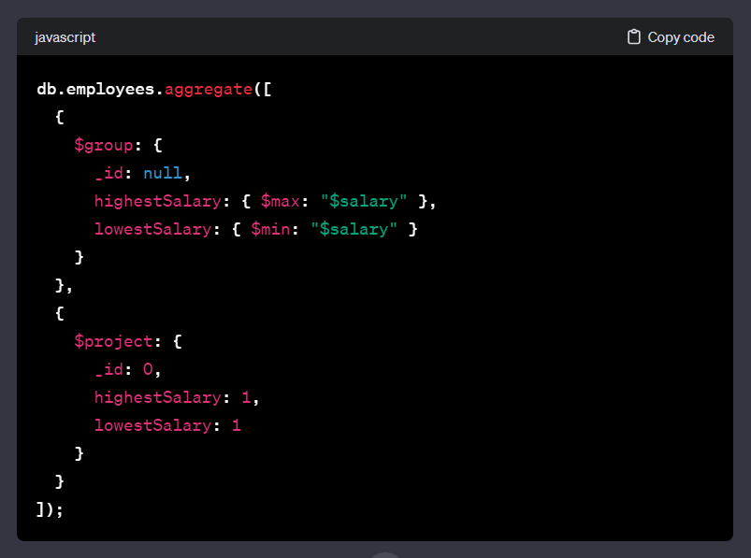

Explanation of each stage:

$group:

Groups all documents as there is no specific grouping criteria (_id: null).

Calculates the maximum salary using $max and stores it in the field highestSalary.

Calculates the minimum salary using $min and stores it in the field lowestSalary.

$project:

Projects only the desired fields to include in the final result.

Excludes the default _id field and includes highestSalary and lowestSalary.

This pipeline will output a single document with the highest and lowest salaries:

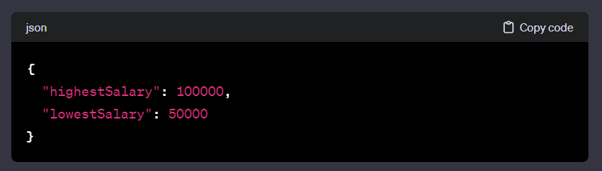

json

Copy code

{

"highestSalary": 100000,

"lowestSalary": 50000

}

1. Provide an example of a MongoDB aggregation pipeline that demonstrates grouping, sorting, and projecting data.

db.products.aggregate([

// Group products by category

{

$group: {

_id: "$category",

averagePrice: { $avg: "$price" },

totalProducts: { $count: {} }

}

},

// Sort the results by average price in descending order

{

$sort: { averagePrice: -1 }

},

// Project only the category, average price, and total products

{

$project: {

category: "$_id",

averagePrice: "$averagePrice",

totalProducts: "$totalProducts"

}

}

])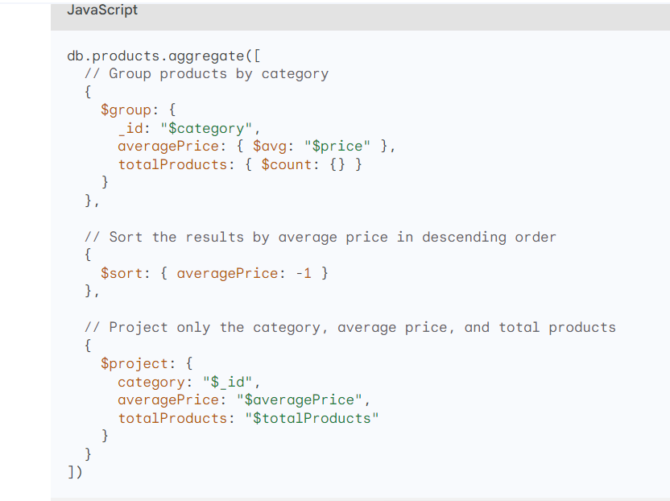

This aggregation pipeline first groups the products by category using the $group stage. Within the $group stage, it calculates the average price of products within each category using the $avg operator and the total number of products in each category using the $count operator.

Next, the $sort stage sorts the results by average price in descending order, showing the categories with the highest average prices first.

Finally, the $project stage projects only the category, average price, and total products, removing any unnecessary fields from the output.

This aggregation pipeline demonstrates how to group, sort, and project data in MongoDB using the Aggregation Framework. It provides a concise and powerful way to analyze and extract meaningful insights from data.

1. Define the concept of functional dependencies in database normalization. Explain how functional dependencies are used to determine candidate keys.

Functional dependencies are a concept within the field of database normalization, specifically in the context of relational databases. They describe the relationships between attributes (columns) in a relation (table) and help ensure that a database is well-organized, minimizing redundancy and anomalies.

**Functional Dependency:**

In a relational database, a functional dependency is a relationship between two sets of attributes in a relation. More formally, if changing the value of one attribute uniquely determines the value of another attribute, we say there is a functional dependency between them.

For example, if we have a relation **R(A, B, C)** where **B** is functionally dependent on **A** (denoted as A → B), it means that for every value of **A**, there is a unique corresponding value of **B**.

**Candidate Keys:**

A candidate key for a relation is a minimal set of attributes that can uniquely identify each tuple (row) in the relation. In other words, it is a set of attributes such that no subset of these attributes can uniquely identify the tuples.

Functional dependencies play a crucial role in determining candidate keys. If we have a set of attributes (let's call it **X**) that functionally determines another attribute (**Y**), then **X** is a superkey. A candidate key is a superkey from which we cannot remove any attributes and still have uniqueness.

Here's how functional dependencies are used to determine candidate keys:

1. **Closure of Attributes:**
   * Determine the closure of a set of attributes by applying all possible functional dependencies to that set. The closure of an attribute set represents all the attributes that can be functionally determined by that set.
2. **Minimal Superkeys:**
   * Identify the minimal superkeys by removing attributes from the closure until further removal results in a loss of uniqueness. These minimal superkeys are potential candidate keys.
3. **Remove Redundancies:**
   * If there are multiple candidate keys, compare them and remove any redundant keys. A redundant key is one that can be expressed as a combination of other candidate keys.
4. **Final Candidate Keys:**
   * The remaining set of non-redundant candidate keys represents the minimal set of attributes needed to uniquely identify each tuple in the relation.

**Example:**

Let's consider a relation **R(A, B, C, D)** with functional dependencies:

* A → B
* B, C → D
* D → A

Here, **{A, B}** and **{D}** are minimal superkeys, but only **{A, B}** is a candidate key as removing any attribute from it would result in a loss of uniqueness.

In summary, functional dependencies help in identifying the closure of attribute sets, which, in turn, assists in determining minimal superkeys and candidate keys for a relation in the process of database normalization.

1. Discuss the factors that influence the choice between a clustered and non-clustered index in a database. Provide specific use cases for each type of index. (Done already)
2. Explain the role of database views in SQL. Provide an example of a view and describe a scenario where using a view is advantageous.

Role of Database Views in SQL:

A database view in SQL is a virtual table that is based on the result of a SELECT query. It does not store the data itself but provides a way to represent the result of a query as if it were a table. Views can be used to simplify complex queries, abstract the underlying data structure, and control access to specific columns or rows.

Key Aspects of Database Views:

Abstraction:

Views allow users to abstract the complexity of underlying tables. Instead of dealing with multiple joins and complex queries, users can interact with the view as if it were a single table.

Security:

Views can be used to control access to certain columns or rows. Users may have permission to access a view without having direct access to the underlying tables.

Simplicity:

Views can simplify query logic by encapsulating complex operations or joins. This promotes code reusability and readability.

Aggregation:

Views can be used to aggregate data, making it easier to obtain summary information without directly querying the base tables.

Column Renaming:

Views allow for the renaming of columns, providing a more user-friendly interface to the data.

Example of a Database View:

Let's consider a scenario where you have two tables, orders and customers, and you want to create a view that combines information from both tables to show order details with customer names.

sql

Copy code

-- Creating a view

CREATE VIEW OrderDetails AS

SELECT

o.OrderID,

o.OrderDate,

c.CustomerName,

o.TotalAmount

FROM

orders o

JOIN customers c ON o.CustomerID = c.CustomerID;

In this example, the OrderDetails view combines data from the orders and customers tables, presenting a unified and simplified perspective.

Scenario Where Using a View is Advantageous:

Imagine a situation where you have a database with sensitive information such as salary details, but you want to provide a view that only exposes non-sensitive information like employee names and department. Instead of granting direct access to the underlying salary table, you can create a view to control and limit the information exposed:

sql

Copy code

-- Creating a view to expose non-sensitive information

CREATE VIEW EmployeeInfo AS

SELECT

EmployeeID,

EmployeeName,

Department

FROM

SalaryInformation;

Now, users can query the EmployeeInfo view without directly accessing the sensitive SalaryInformation table. This helps in maintaining data security and privacy.

In summary, database views in SQL offer a way to abstract, simplify, and secure access to data by providing a virtual representation of the results of a query. They are advantageous in scenarios where data abstraction, security, and simplified query interfaces are desired.

1. Explain the purpose and benefits of database constraints in ensuring data integrity. Provide examples of common constraints used in relational databases.

Database constraints play a crucial role in ensuring data integrity within a relational database. Data integrity refers to the accuracy, consistency, and reliability of data stored in a database. Constraints are rules or conditions that are applied to columns or tables to maintain the quality and validity of the data. They help prevent the entry of inconsistent, invalid, or inaccurate data, ultimately enhancing the reliability and usefulness of the database.

Benefits of Database Constraints:

Data Accuracy:

Constraints ensure that the data entered into a database conforms to predefined rules, reducing the likelihood of errors and inaccuracies.

Consistency:

Constraints maintain consistency by enforcing relationships and rules between tables, preventing conflicting or contradictory data.

Data Quality:

By restricting the types and values of data that can be inserted or updated, constraints contribute to the overall quality of the data stored in the database.

Prevention of Orphaned Records:

Foreign key constraints help maintain referential integrity by preventing the creation of orphaned records (records without a corresponding reference in another table).

Security:

Constraints can enhance data security by restricting certain operations, preventing unauthorized users from modifying or deleting critical data.

Ease of Maintenance:

Constraints simplify database maintenance by automating data validation and reducing the need for manual error checking and correction.

Improved Performance:

Well-defined constraints can lead to better execution plans for queries, resulting in improved database performance.

Examples of Common Constraints in Relational Databases:

Primary Key Constraint:

Ensures that each row in a table is uniquely identified. No two rows can have the same primary key value.

sql

Copy code

CREATE TABLE Employees (

EmployeeID INT PRIMARY KEY,

EmployeeName VARCHAR(50),

...

);

Foreign Key Constraint:

Establishes a link between two tables by ensuring that values in a specified column of one table match the values in a primary key column of another table.

sql

Copy code

CREATE TABLE Orders (

OrderID INT PRIMARY KEY,

CustomerID INT,

FOREIGN KEY (CustomerID) REFERENCES Customers(CustomerID)

);

Unique Constraint:

Ensures that all values in a specified column are unique.

sql

Copy code

CREATE TABLE Students (

StudentID INT UNIQUE,

StudentName VARCHAR(50),

...

);

Check Constraint:

Enforces a condition on the values allowed in a column.

sql

Copy code

CREATE TABLE Products (

ProductID INT,

QuantityInStock INT,

CHECK (QuantityInStock >= 0)

);

Not Null Constraint:

Ensures that a column cannot contain NULL values.

sql

Copy code

CREATE TABLE Customers (

CustomerID INT PRIMARY KEY,

CustomerName VARCHAR(50) NOT NULL,

...

);

In summary, database constraints are essential for maintaining data integrity by enforcing rules and relationships within a relational database. They contribute to data accuracy, consistency, and overall quality, making the database a reliable and trustworthy source of information.

1. Describe the purpose and characteristics of NoSQL databases. Provide examples of NoSQL database types and explain when it's appropriate to use them in data storage and retrieval.

NoSQL databases, also known as non-relational databases, are a diverse group of database systems that store and manage data differently than traditional relational databases (RDBMS). Unlike RDBMS, which adhere to a rigid schema with normalized data, NoSQL databases offer flexibility and scalability, making them suitable for handling large volumes of unstructured or semi-structured data.

Purpose of NoSQL Databases

NoSQL databases are designed to address the limitations of RDBMS in handling modern data requirements, particularly for applications dealing with vast amounts of unstructured or semi-structured data. They offer several advantages over RDBMS, including:

1. Scalability: NoSQL databases are horizontally scalable, meaning they can distribute data across multiple nodes, enabling seamless scaling to accommodate increasing data volumes and user demands.
2. Flexibility: NoSQL databases provide flexible data models, such as document-oriented, key-value, graph, and columnar, allowing them to store a wide range of data formats without rigid schema constraints.
3. Performance: NoSQL databases are often optimized for performance, particularly for read-heavy workloads, making them suitable for applications that require high throughput and low latency.

Types of NoSQL Databases

1. Document-oriented databases: These databases store data in JSON-like documents, allowing for flexible data structures and nesting. Examples include MongoDB and CouchDB.
2. Key-value databases: These databases store data as key-value pairs, offering fast retrieval based on unique keys. Examples include Redis and Riak.
3. Graph databases: These databases store data as a network of interconnected nodes and edges, representing relationships between entities. Examples include Neo4j and OrientDB.
4. Columnar databases: These databases store data in columns, allowing for efficient data compression and filtering. Examples include Cassandra and HBase.

When to Use NoSQL Databases

NoSQL databases are well-suited for scenarios where:

1. Scalability is a primary concern: NoSQL databases can handle large volumes of data without significant performance degradation.
2. Data is unstructured or semi-structured: NoSQL databases can store and manage unstructured or semi-structured data effectively.
3. Schema flexibility is required: NoSQL databases allow for dynamic data models, adapting to changing data requirements.
4. Performance is critical: NoSQL databases often offer faster query performance, particularly for read-heavy workloads.
5. Consistency trade-offs are acceptable: NoSQL databases may offer eventual or causal consistency, which is less strict than ACID compliance in RDBMS.

Examples of NoSQL Database Applications:

1. Social media platforms: Store user profiles, posts, and interactions in a flexible and scalable manner.
2. E-commerce platforms: Manage product catalogs, user profiles, and order data efficiently.
3. Real-time analytics platforms: Process and analyze large volumes of streaming data for real-time insights.
4. Mobile and IoT applications: Store and manage unstructured data from user interactions, sensor readings, and device logs.
5. Content management systems: Handle unstructured content such as blog posts, images, and videos.
6. What is the primary purpose of a database management system (DBMS), and how does it differ from a traditional file system for data storage?

A Database Management System (DBMS) is a software system that is designed to manage and organize data in a structured manner. It allows users to create, modify, and query a database, as well as manage the security and access controls for that database.

The primary purpose of a Database Management System (DBMS) is to efficiently and securely manage and organize data. A DBMS serves as an interface between the application programs and the physical data storage. It provides a set of tools and services to create, retrieve, update, and manage data in a structured and organized manner. The key objectives of a DBMS include:

1. **Data Abstraction:**
   * The DBMS abstracts the underlying complexities of data storage, providing a logical view of the data to users and applications.
2. **Data Integrity:**
   * Ensures the accuracy and consistency of data by enforcing constraints, relationships, and validation rules.
3. **Data Security:**
   * Implements access control mechanisms to restrict unauthorized access to data and ensure data confidentiality.
4. **Concurrency Control:**
   * Manages concurrent access to the database by multiple users or applications, preventing conflicts and ensuring data consistency.
5. **Data Independence:**
   * Provides independence between the physical storage structure and the logical representation of data, allowing changes in one without affecting the other.
6. **Data Retrieval and Query Processing:**
   * Offers query languages (e.g., SQL) and optimization techniques to efficiently retrieve and process data based on user requirements.
7. **Data Recovery:**
   * Implements mechanisms for backup and recovery to safeguard data against loss or corruption.

**Differences from a Traditional File System:**

1. **Data Structure:**
   * **File System:** Data is organized into files and directories, typically with a hierarchical structure.
   * **DBMS:** Data is organized into tables, rows, and columns, following a relational or non-relational model.
2. **Data Relationships:**
   * **File System:** Limited support for defining and maintaining relationships between pieces of data.
   * **DBMS:** Supports the establishment of relationships between tables through keys, enforcing referential integrity.
3. **Data Redundancy:**
   * **File System:** May result in data redundancy as the same information may be stored in multiple files.
   * **DBMS:** Minimizes redundancy through normalization techniques, reducing the risk of inconsistencies.
4. **Data Access and Retrieval:**
   * **File System:** Requires custom code for data access, and retrieval may involve reading entire files.
   * **DBMS:** Provides a query language (e.g., SQL) for simplified and efficient data access and retrieval.
5. **Concurrency and Transaction Management:**
   * **File System:** Limited support for handling concurrent access and ensuring transaction consistency.
   * **DBMS:** Implements sophisticated concurrency control and transaction management mechanisms.
6. **Data Integrity and Constraints:**
   * **File System:** Lacks built-in mechanisms for enforcing data integrity and constraints.
   * **DBMS:** Enforces data integrity through constraints, reducing the likelihood of erroneous or inconsistent data.
7. **Scalability:**
   * **File System:** May face challenges in scaling for large volumes of data or concurrent access.
   * **DBMS:** Designed to scale efficiently, handling large datasets and providing mechanisms for horizontal and vertical scaling.

In summary, while a traditional file system is suitable for basic storage and retrieval of files, a DBMS provides a more structured, efficient, and secure approach to manage and organize data, especially in scenarios where data relationships, integrity, and complex queries are essential.

Top of Form